Structured Programming Design Report

# Introduction

I have been tasked with creating a program in Python 3 that will analyse cascade circuits. The circuit below is an example of such circuits.

This program is to receive an input file, analyse the input file and then produce an output file which contains information requested by the input file.

# Task Details

As stated above I am tasked with the creation of a program that produces an output file upon receiving an input file.

## Input File

The input file describes the circuit. It contains three sections:

1. <CIRCUIT>
2. <TERMS>
3. <OUTPUT>

The <CIRCUIT> section contains values of resistances, conductances and the node numbers of the start and end of the circuit components.

An example circuit blocks looks like this

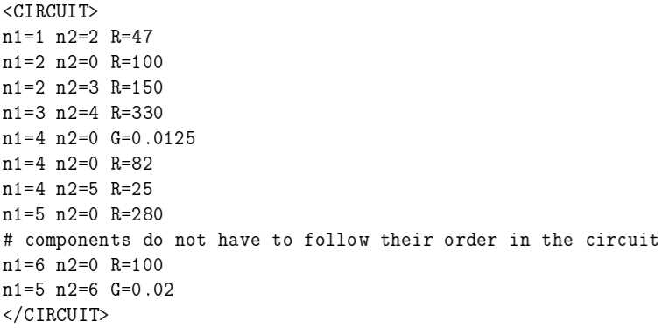

The <TERMS> section contains values for the circuit voltage and current sources.

The <OUTPUT> sections describes how the output file should be. This includes the filename, which variables to include, the order of the variables and the units for the variables. Here is an example output block:

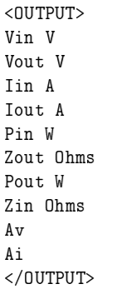

## Output File

The output file is to contain values specified by the <OUTPUT> section of the input file. An example output file produced may look like this:

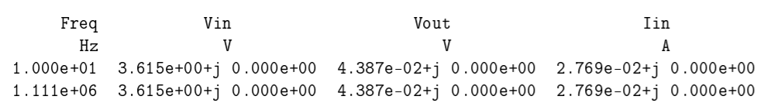

## Methodology

The program is to read the input file, extract the necessary data from it and then calculate the desired output values. These values are to be calculated by analysing the circuit using Chain Matrix Analysis.

# Program Flow

## Read input file

This is done by using open(filename, mode)

## Analyse input file

The file needs to be analysed and necessary values need to be extracted. This is done by filename.readlines() which will store the individual lines of the file in a variable. This can then be looped through line by line, then using logic (if statements etc), we can ignore all the commented sections and unnecessary information. Before doing all this we can set empty variables for values such as nodes, resistance, conductance, voltage sources, current sources etc. Then while looping through the lines, we can extract theses values and insert them into their variables that we declared at the start of the program.

## END

# Testing

In order to test that my program is working as expecting, I will run my program using already prepared test input files which contain already made expected output files. I will then compare the output files generated from my programs with the premade output files. If they match, then my program is working as expected. If not, then something is wrong and I will have to edit my program.